Name______________ Date_________ Period______
Motion Quiz
1.What is Newton's second law of motion?
- F=Ma
- Every action has its equal and opposite reaction
- The law of inertia
- CPMS
2. A slug crawls by a twig in a grassy field. What is its reference point? *
- The Twig
- The Sun
- It's Shell
- The Field
3. A force of 32N is applied to a boat with a mass of 8kg. What is the acceleration of the boat?
- 4m/s^2
- Mass
- 1440.6N
- 3 m/s^2
4. A 245N bowling ball weighs 25kg. What is the acceleration of the ball due to gravity?
- 9.8m/s^2
- 500 kg
- Inertia
- 16 kg
5. Pushing or pulling on an object
- Force
- 9.8m/s^2
- kilograms
- Balanced Force
6. What force is needed to accelerate a 22kg mass across a surface of 12.5m/s^2?
- 275 N
- 500 kg
- Balanced Force
- 16 kg
7. What label do you use when solving for Force/Weight?
- Newtons
- 16 kg
- Action Force
- Balanced Force
8. What label do you use when solving for acceleration?
- m/s^2
- Newtons
- Newton's second law
- 275 N
9. A force of 48N is applied to a 16kg mass. What is the acceleration?
- 3 m/s^2
- 9.8m/s^2
- 4m/s^2
- 1440.6N
10. What is the mass of a dog that has a force of 64N and is moving with an acceleration of
- 4m/s^2?
- 16 kg
- 30 kg
- 3 m/s^2
11. Intertia
- an object with large amounts of mass and high speeds will also have a lot of
- the rubbing of two surfaces together
- what happens if the amount of friction increases on an object
- these ends of the magnet repel each other
12. Distance/Time
- how is speed calculated
- what happens to speed if you apply a force in the direction the object is moving
- if the object is moving the forces are
- these ends of the magnet attract to each other
13. A baseball has a momentum of 6.0 kg.m/s south and a mass of 0.15 kg. What is a baseball's velocity?
- v = 40 m/s south
- v = 0.025 m/s north
- v = 0.9 m/s south
- Answer not given.
14. The rate of change of an object's position
- Speed
- Velocity
- Acceleration
- Momentum
15. Any change over time
- rate
- speed
- mass
- displacement
16. Speed
- distance traveled divided by the time it takes
- how fast an object is moving at the beginning
- on a DISTANCE-TIME graph a line that is horizontal (side to side) shows an object that is
- m/s, mi/hr, ft/day
17. Motion
- Change in position of an object
- the product of an object's mass and its velocity
- m/s, mi/hr, ft/day
- distance traveled divided by the time it takes
18. Acceleration
- the rate at which velocity changes over time
- on a DISTANCE-TIME graph a line that is straight and diagonal shows _______________motion
- m/s north, mi/hr up, ft/day forward
- Change in position of an object
19. Reference point
- a stationary object used to compare motion
- how far apart an object is from where it started to where it ended
- the rate at which velocity changes over time
- on a SPEED-TIME graph a line that is horizontal (side to side) shows an object that
20. Labels for speed
- m/s, mi/hr, ft/day
- m/s north, mi/hr up, ft/day forward
- Change in position of an object
- on a DISTANCE-TIME graph a line that is horizontal (side to side) shows an object that is ________________

21. Velocity is
- speed in a certain direction
- how fast an object is moving at the end
- the rate at which velocity changes over time
- on a DISTANCE-TIME graph a line that is horizontal (side to side) shows an object that is ________________
22. Distance
- how far apart an object is from where it started to where it ended
- on a DISTANCE-TIME graph a line that is horizontal (side to side) shows an object that is ________________
- how fast an object is moving at the end
- speed in a certain direction
23. Momentum is
- the product of an object's mass and its velocity
- speed in a certain direction
- how fast an object is moving at the end
- how far apart an object is from where it started to where it ended
24. Newtons 3rd Law of Motion
- Action --> Reaction
- Blue
- Acceleration is the same as the Net Force Applied to that Objects mass
- Jay Cutler
25. Newtons 1st Law of Motion
- An Object that is in rest tends to stay in rest
- Isaac Newton
- Acceleration is the same as the Net Force applied to an objects mass
- Action --> Reaction
26. Acceleration is the same as the Net Force Applied to that Objects mass
- 2nd Law
- 3rd Law
- 1st Law
- 76th Law
27. 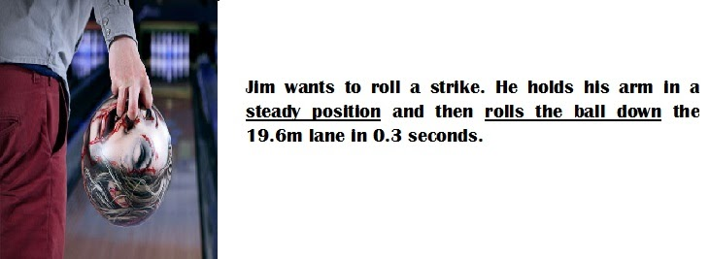
28. About how fast was the bowling ball rolled down the lane?
- 65 mph
- 88 mph
- 66 mph
- 67 mph
29. A force must be applied in order for motion to occur.
- True
- False
30. Sir Issac Newton was the guru of motion.
- True
- False
31. Short Answer Question: Describe Newton’s Three Laws of Motion and give an example of each law. Answer should be at least 5 complete sentences. 10 points.
____________________________________________________________________________________________________________________________________________________________________________________________________________________________________________________________________________________________________________________________________________________________________________________________________________________________________________________________________________________________________________________________________________________________________________________________________________________________________________________________________________________________________________________________________________________________________________________________________________

