Name ______________________ date_________ period ____
1 Exothermic and endothermic reactions
Decide whether each of these reactions is exothermic or endothermic:
- When two chemicals mix their temperature rises: _______________
- A solid burns brightly and releases heat, light and sound: _______________
When two chemicals are mixed their temperature drops: _______________
- Two chemicals will only react if you heat them continually: _______________
- Plants take in light energy for photosynthesis: _______________
Identifying Endothermic vs Exothermic Reactions
Decide whether each of these scenarios is exothermic or endothermic. | Endothermic or Exothermic reaction? | Explain Why?
1. An ice cube melts after being left out on the table.
2. Cooking an egg in a frying pan.
3. Burning a match.
4. The human body uses the energy provided from food digestion.
5. Morning dew forming on grass and plants.
6. Dynamite explodes in the destruction of a building.
7. Making ice cubes.
8. A puddle of water evaporates.
9. Plants making sugar through photosynthesis
10. Snowman melting after the sun shines on it
11. Converting frost to water vapor.

2 Making and breaking bonds
During chemical reactions the bonds between atoms break and new bonds form.
Energy must be absorbed to break a bond, so breaking bonds is endothermic.
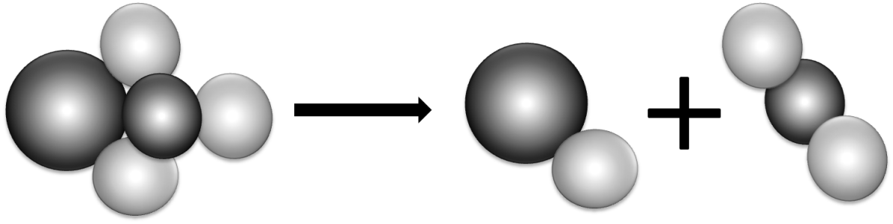
Making new bonds is exothermic because energy is released.
- When green copper carbonate decomposes, the equation is:

CuCO₃ | CuO | CO₂
copper carbonate | copper oxide | carbon dioxide

Is the reaction exothermic or endothermic? Use ideas about bonds to explain why.
________________________________________________________________________
- Draw diagrams to show what happens when hydrogen reacts with oxygen. Mark the bonds broken in blue and the new bonds formed in red. The equation is:

2H₂  hydrogen | + | O₂  oxygen |  | 2H₂O  water

3 ‘Make or break’
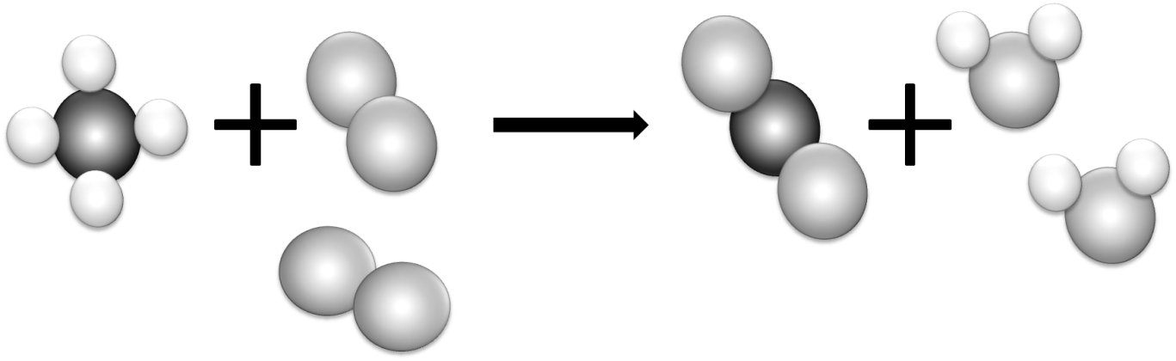
- Most reactions involve bond breaking and bond making. This equation shows what happens when methane (CH₄) burns in oxygen (O₂).
Mark the bonds broken with a “B” and the bonds formed with an “R”.

- Complete the table to show the number of bonds broken and formed:
Bonds broken | Number | Bonds formed | Number
between carbon and hydrogen |  | between carbon and oxygen
between oxygen atoms |  | between hydrogen and oxygen

- Is the reaction exothermic or endothermic overall?
________________________________________________________________________
- The overall energy change is decided by the strength of the bonds that are broken or formed during the reaction. The stronger the bond the larger the energy change.
Which bonds are stronger in this reaction – the bonds broken or the new bonds formed?
________________________________________________________________________

1 Comparing fuels
A student wanted to compare the energy released when 4 different fuels burned. These are her results:
Hint: subtract the ending temperature from the starting temperature.
Fuel | Temperature at the start in °C | Temperature at the end in °C | Temperature rise in °C
methanol | 25 | 56
ethanol | 18 | 53
propanol | 17 | 54
butanol | 23 | 63

- Calculate each temperature rise and state which fuel releases most energy.
________________________________________________________________________
Another student used spirit burners for the experiment. She had to weigh them before and after each test to find out how much fuel she had used. To make it a fair test she used each fuel to make the same amount of water 10°C hotter. These are her results:
Fuel | Mass of burner at the start in g | Mass of burner at the end in g | Mass of fuel used in g
methanol | 154.3 | 150.7
ethanol | 213.4 | 210.6
propanol | 185.8 | 183.4
butanol | 198.5 | 196.3

- Calculate the mass of each fuel she had to use to release the same amount of energy, and state which fuel must release more energy
________________________________________________________________________
- What could these students do to prove their results were repeatable?
________________________________________________________________________
- Results are reproducible if they lead to the same conclusions when different people do the experiments or when different methods are used. Are the results reported on this page reproducible?
________________________________________________________________________

